STRIKE GALAXY ATTACK-CHICKEN INVADERS
CONTENTS
1. Game Description:
2. Config
2.1. Admob
2.2. Unity Ads
2.3. Leaderboard ( Android) & Game Center( iOS)
2.4. IAP( In-Apps Purchase)
2.5. Time Reward and FreeCoins with Unity Ads
3. How to Resin
4. How to edit Waves/ Add more Waves / Add more level
4.1. How to create,edit a Wave in this game
4.2. Detail example
4.3. Add More Wave in level
4.4. Add More Level
5.Note:
6.Important note when building iOS

--------------------------------------------------------------------------------------------------------

1. Game Description: (Back to top)
1.1.Engine and component:
1.1.1. Unity 5.6.3f1,Build with Mac OS 10.13- Xcode 9.2
1.1.2. GooglePlayGamesPlugin-0.9.39a
1.1.3. Google Mobile Ads Unity Plugin v3.13.1
1.1.4. Unity Ads v 2.2.1 (The latest version is June 2, 2018)
1.1.5. Unity IAP v1.19.0 (The latest version is June 2, 2018)
*All have been integrated into the project!You don't need to import anything else!
1.2. Cross platform (Googleplay, iTunes..etc)

2. Config (Back to top)
2.1. Admob
In Unity Editor:
2.1.1. Go Assets -> ChickenInvaders->Scenes-> "Main" Scene.
2.1.2. In "Main" scene, find "Admob" object in Hierarchy tab.
2.1.3. Select "Admob" object, insert your admob id here->Done!
2.2. Unity Ads
In Unity Editor:
2.2.1. Window-> Service ->Settings-> Unlink,Rename project.
2.2.2. Window-> Service ->Goto Dashboard-> Find your UnityAds id, Copy it.
2.2.3. In Unity Editor ,Go Assets -> ChickenInvaders->Scenes-> "Main" Scene.
2.2.4. In "Main" scene, find "UnityAds" object in Hierarchy tab.
2.2.5. Select " UnityAds " object, insert your UnityAds id here->Done!
2.3. Leaderboard ( Android) & Game Center( iOS)
* Android:
2.3.1. In Unity Editor, Go File->Build Settings-> Player Settings-> Other Settings-> Identification -> Change "Package Name", "Version","Bundle Version Code"
2.3.2. Unity Editor, Go File->Build Settings-> Player Settings-> Publishing Settings-> Create New keystore -> fill your information in your keystore
2.3.3. Get SHA1 code: Follow these instructions
https://www.youtube.com/watch?v=aakXkUY6MYU

2.3.4. In Google Console Developer:
- Open "Game Service" tab-> "Add New Game" -> Link Apps -> Copy and Paste "Package Name" (Create in step 2.3.1) -> Continue Next Step -> Copy And Paste SHA1 code (Get in step 2.3.3)
- Click in Leaderboards -> Add new leaderboard (Currently there are 3 leaderboards in this project: High Score, Unlock Maps and Total Coins- Open LeaderboardController.cs to more information- You can use them or create your own leaderboards)
- Get resources (XML file), Copy it
2.3.5. Back in Unity Editor: Go Window-> Google Play Games ->Setup -> Android setup-> Paste resources file in correct blank
2.3.6. In "Main" scene, find " LeaderBoard" object in Hierarchy tab -> Insert your leaderboard id ->Done!
* iOS:
- Open LeaderboardController.cs-> Copy leaderboard string
- Go Developer.apple.com -> Create provisioning profile
- Go iTunes Connect -> Create new game ->... -> Features-> Game Center -> Create leaderboard -> paste leaderboard string in first step ->Save -> Done!

2.4. IAP( In-Apps Purchase)
- Open Purchase.cs ->Change your product id (Creat on Google Play
Console or Itune Connect). You can change the price of IAP packages in this script.
*With Google Play Console, you have to upload apk file, then creat items product id
(Tip: create a list of items product id, after uploading the file for publish,creat it on
Google Play Console).
* You do not have to change anything in Purchase.cs when switch between android
and iOS. It works on both Android and iOS.
*You must turn on IAP in services of Unity ( In Unity Editor ,Window -
>Sevices(Turn on IAP included Turn On Analytics!))
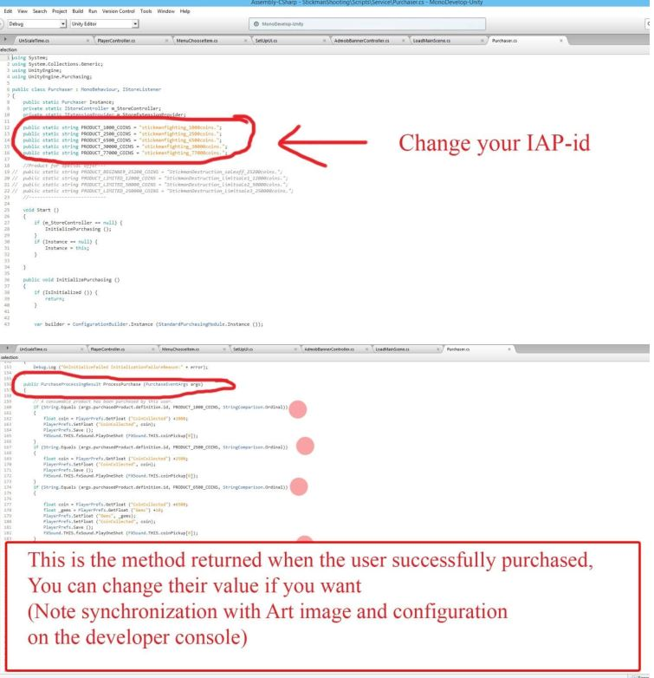
2.5. Time Reward and FreeCoins with Unity Ads
*Time Reward:
-In "Main" scene, find " DailyRewardController" object in Hierarchy tab -> Change time to get reward coins (Hours,Minutes,Seconds). For information you can open DailyRewardController.cs
* FreeCoins:
-In "Main" scene, find " FreeCoinController" object in Hierarchy tab -> Change time to get reward coins (Hours,Minutes,Seconds), note that: Users will only be able to watch up to 10 Unity videos during the above period. For information you can open DailyRewardController1.cs & FreeCoinRewardUI.cs

3. How to Resin (Back to top)
3.1.UI
All GUI images can be found in: Assets-> ChickenInvaders -> SourcesImage -> UI . They are arranged in the order of their screens and function names, which are named according to the principle of Screen Order_Scene Name_Function Name. Example The Adventure button on the Home screen is named 1Home_Adventure.
3.2. Player character,Enemies,Item & Effects
3.2.1. Image: All image of them you can find in: Assets-> ChickenInvaders -> SourcesImage-> Effect,Main Bullet
3.2.2. Prefabs: All prefabs of Player,enemy,item,effects in : Assets-> ChickenInvaders -> Prefabs
*You can drop them into the Hierarchy tab and change the parameters of sprite, animation or partical for them. Note "Apply" these prefabs after the change.
4. How to edit Waves/ Add more Waves / Add more level
4.1. How to create,edit a Wave in this game
4.1.1 Create a grid in the format: Row x Column:33x19. Points on the path of grid are listed under the name of the Row.Column no. For example, the second point in row 1, named 1.2 (where: 1 is the row name, 2 is the column name of that row)

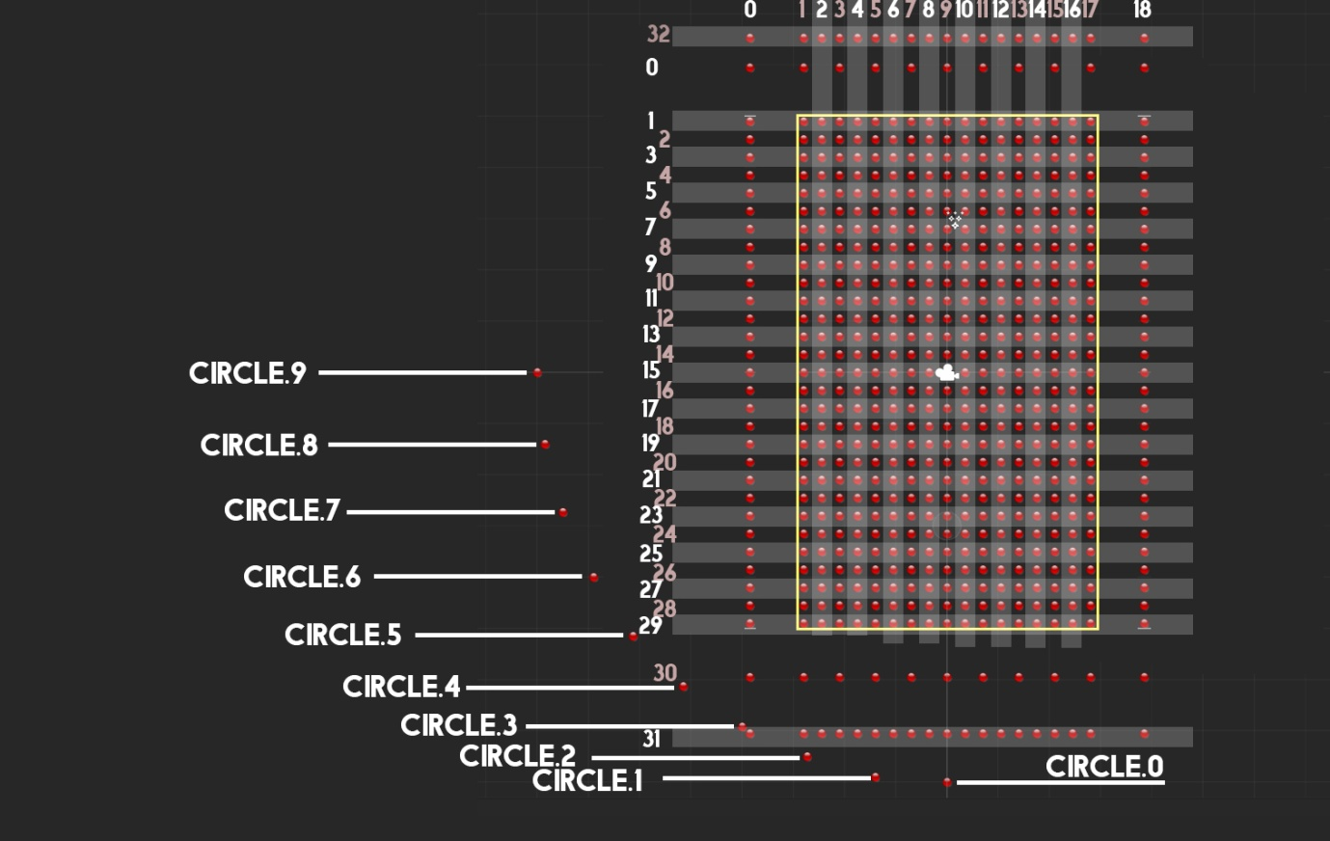
4.1.2 The chicken will move on the selection point on this grid
4.2. Detail example
*To make a chicken move same the " wave1" of "level1" in this game (Play wave 1 in level 1 of this game to see it) do the following
-Step1: Spawn the first chicken to move along the "Waypoints" as shown in figure, from position 17.18-> 17.16-> 6.16-> 6.3 (number1)
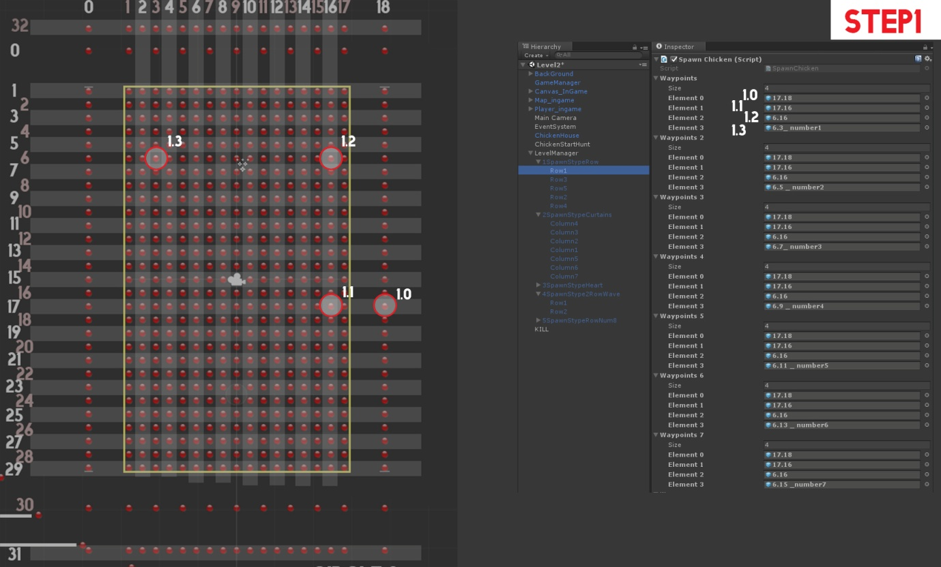
-Step2: Spawn the second chicken to move along the "Waypoints" as shown in figure, from position 17.18-> 17.16-> 6.16-> 6.5 (number1)
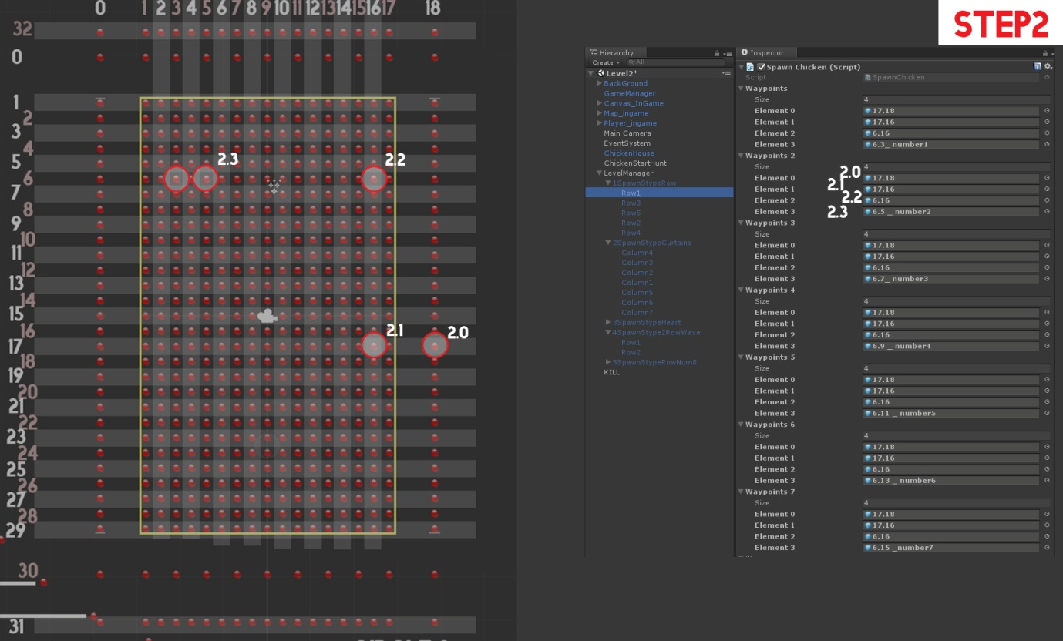

-Step3 to Step7 keep going the same way as the Waypoints3 to Waypoints7 to spawn chicken and create the first row (Row1) as shown in the picture.
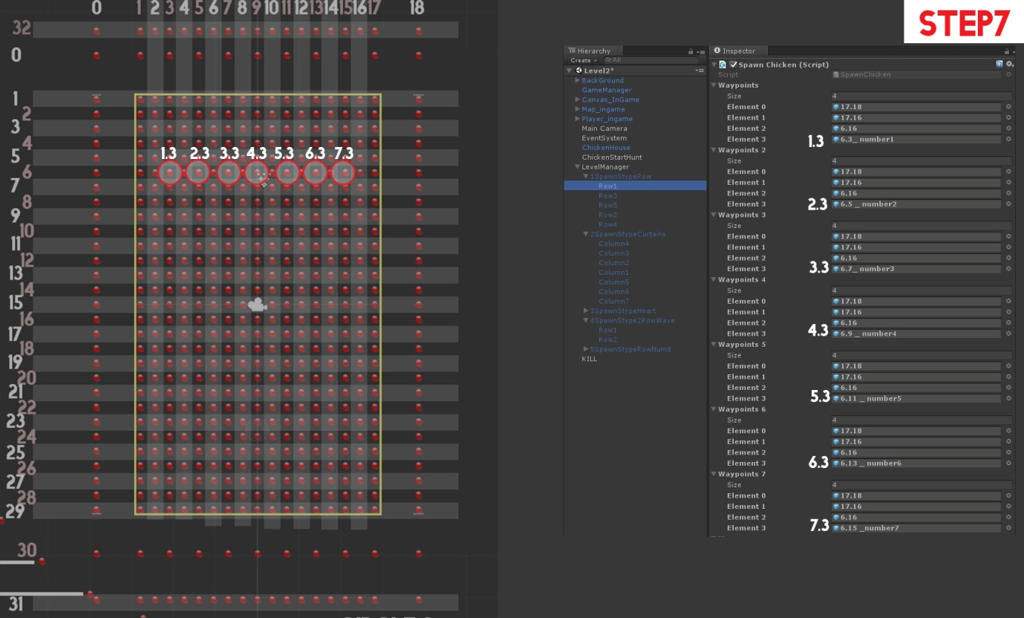

*Important parameters
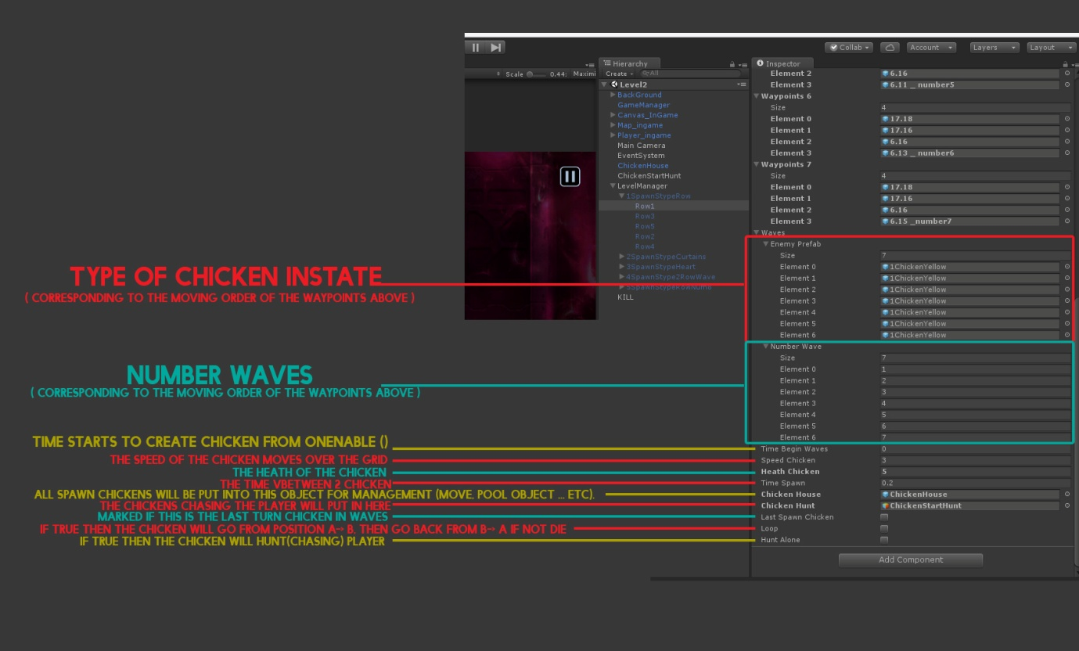
4.3. Add More Wave in level
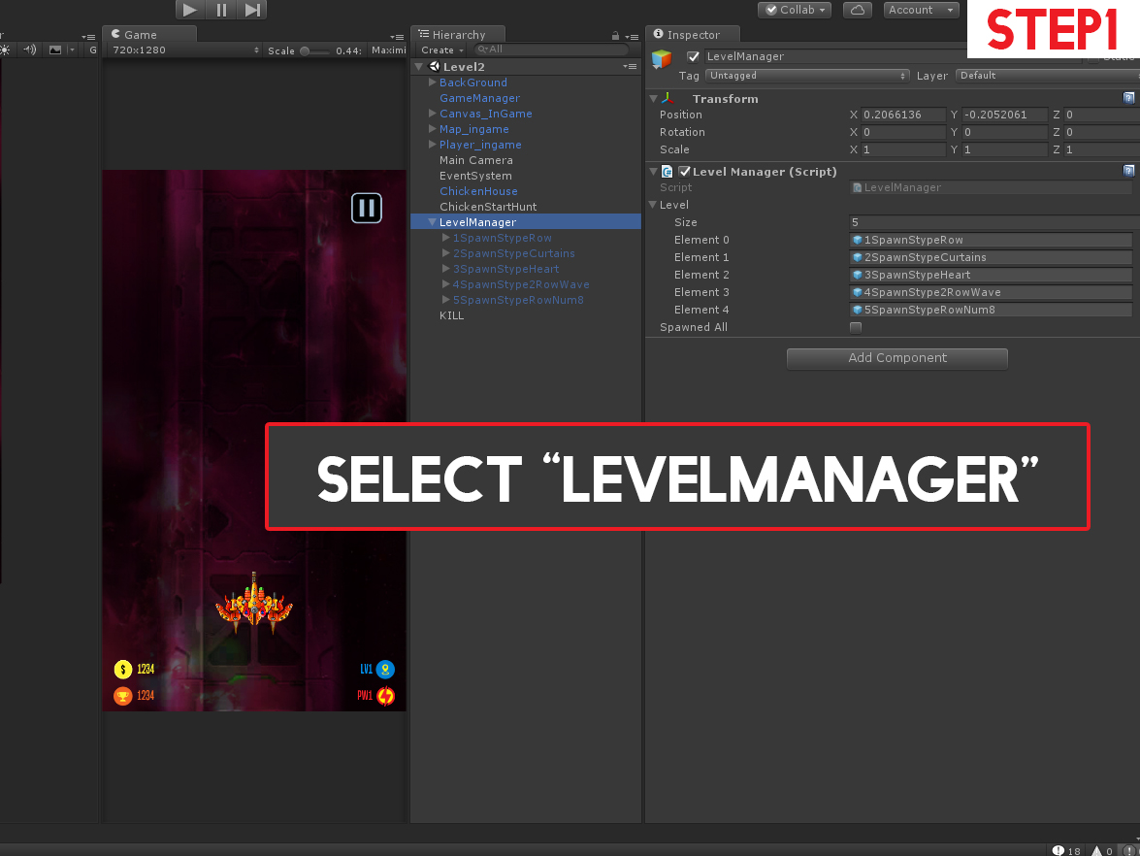
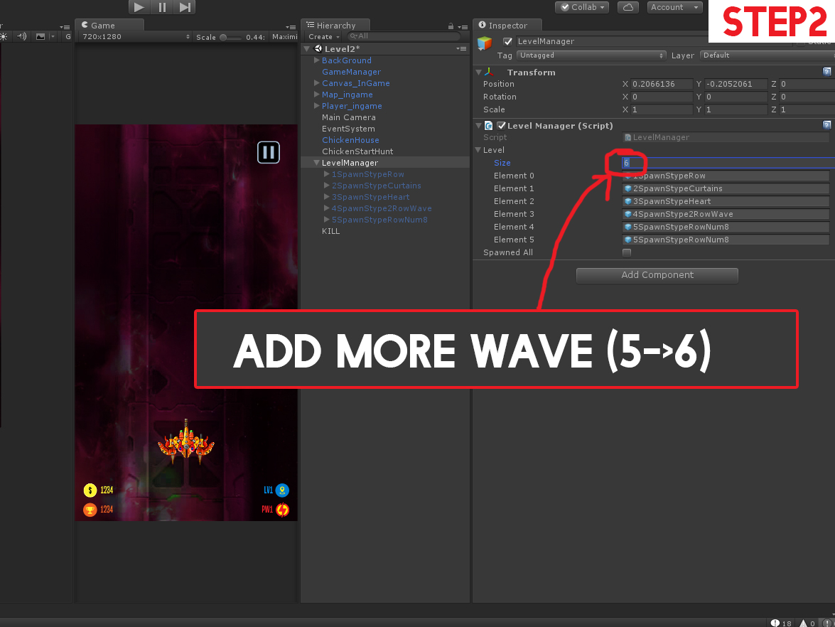
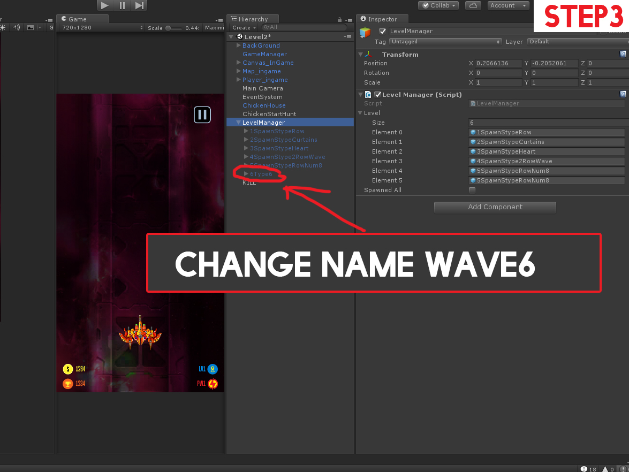
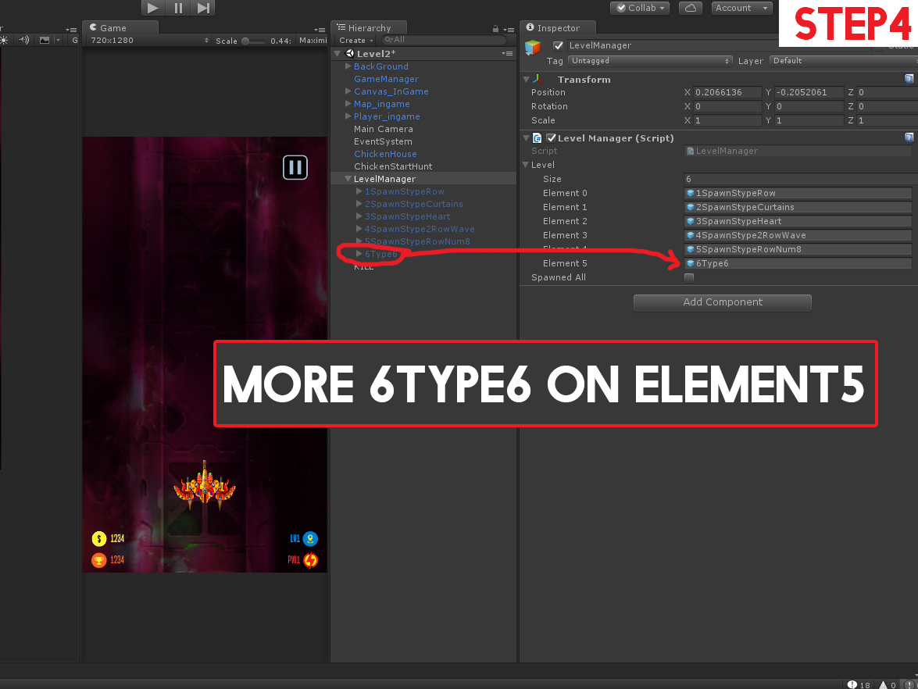
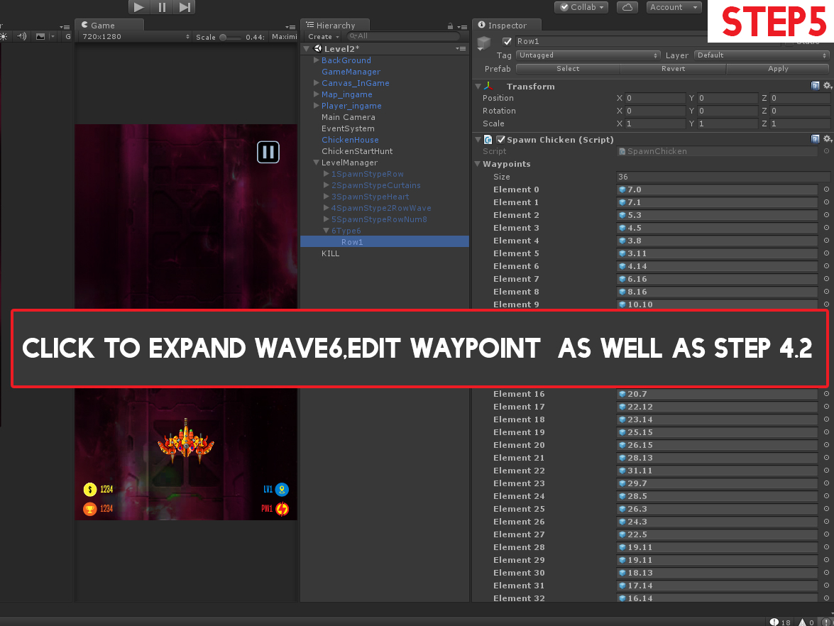
4.4. Add More Level
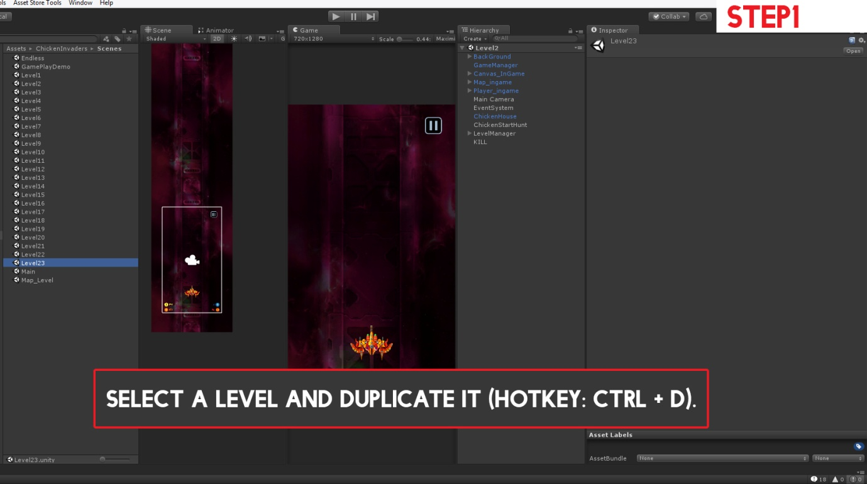
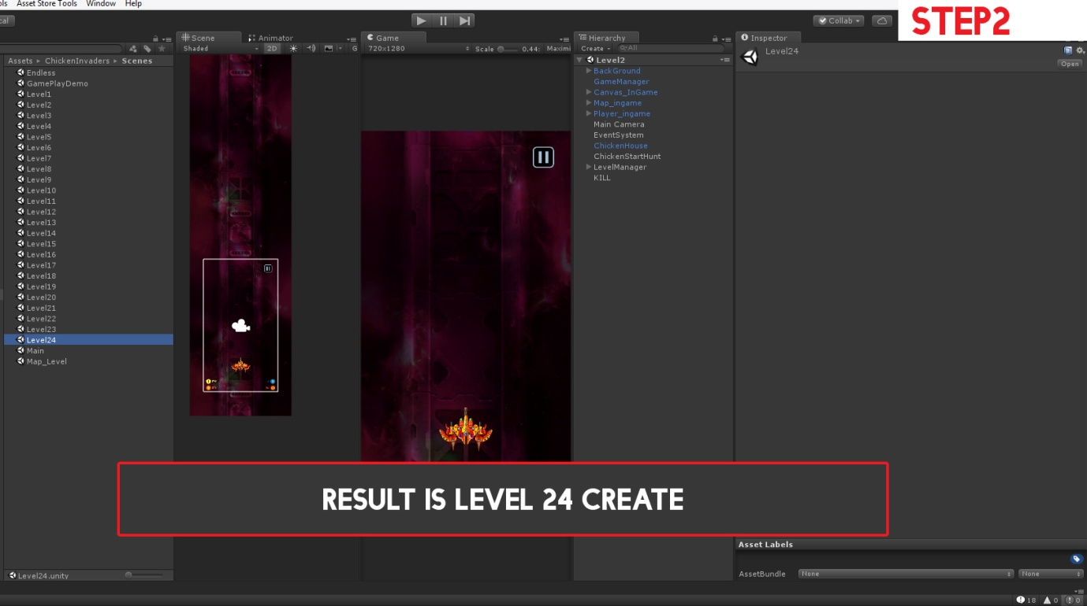
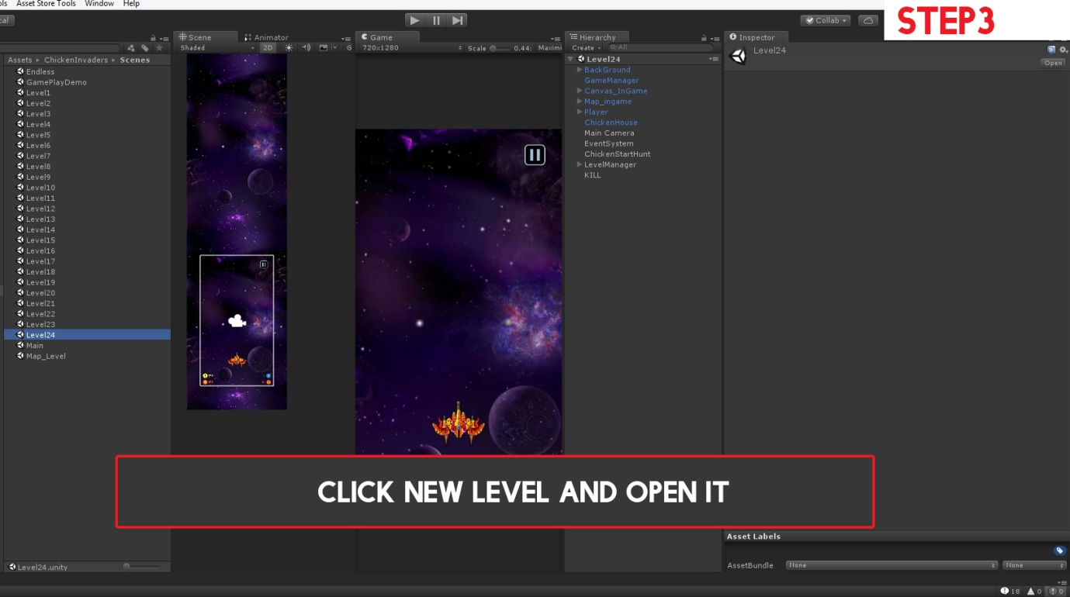
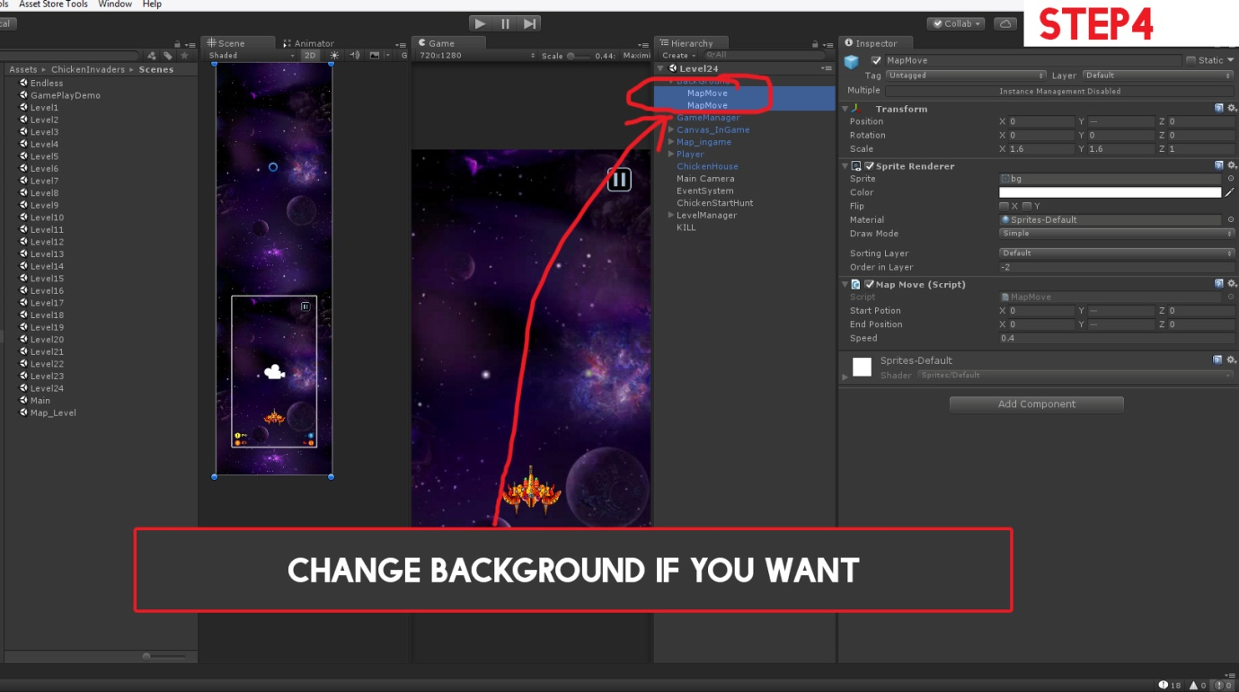
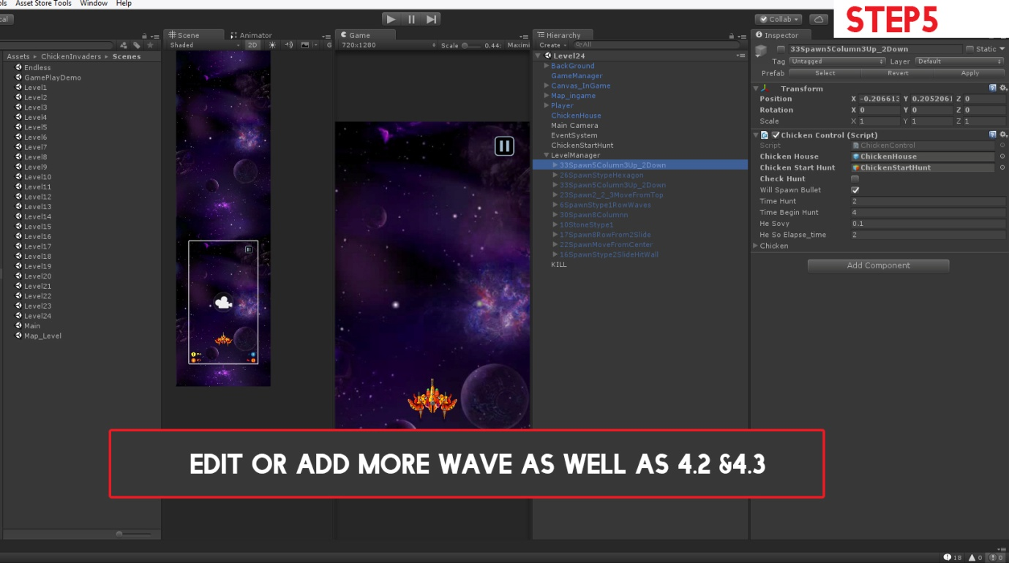
-Step 6: The config steps on the editor do the following video:
https://drive.google.com/file/d/1aHY1mAlFCarYyYIIx1EgXPIi2HAaPl-X/view
https://drive.google.com/file/d/1d1bNNefxdeP0ccPB8PAEO1inEpZHFDGG/view

5.Note: (Back to top)
-1. Do not leave these two objects = null, always select Chicken House and Chicken Start Hunt when creating new waves or edit waves
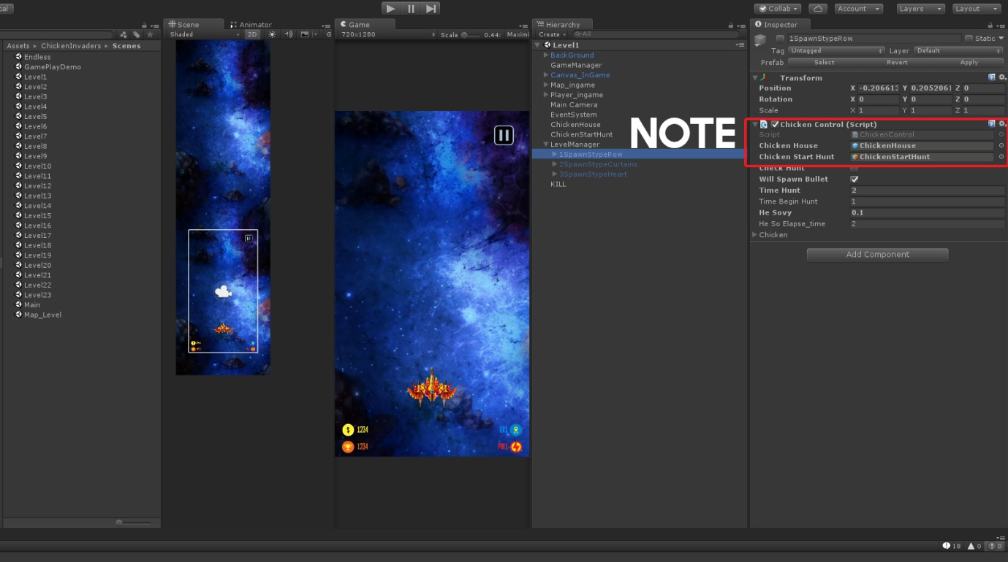
-2.
- Check hunt = true means that the whole shape will in turn chase chickens
-Will Spawn bullet = true means that the whole shape will spawn bullets

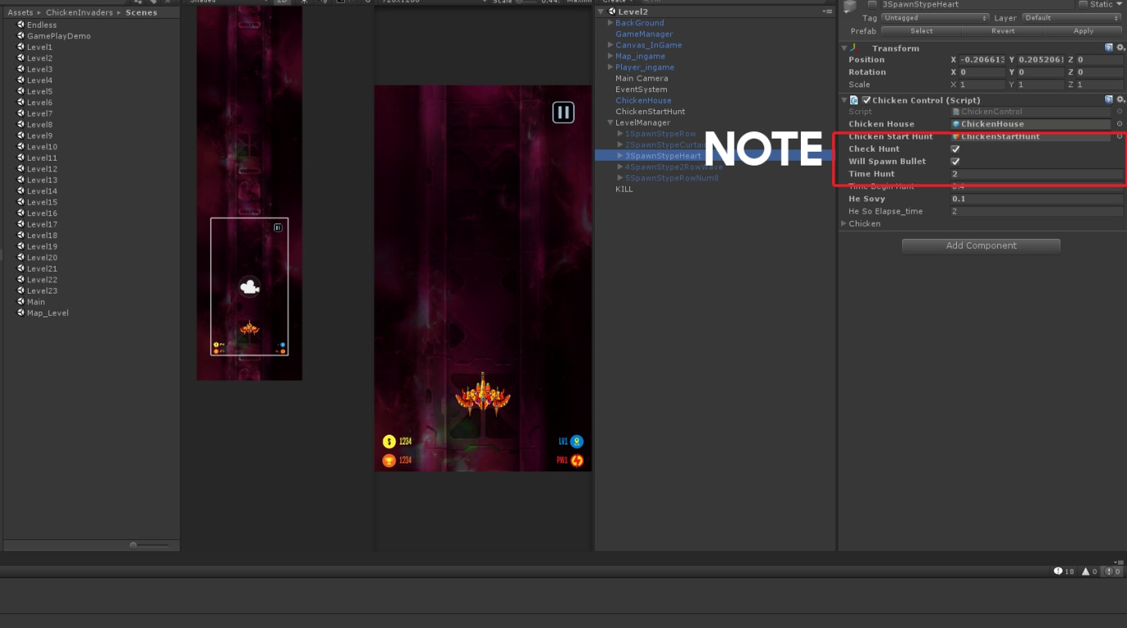
-3. In any shape created, always mark the last wave created by this shape
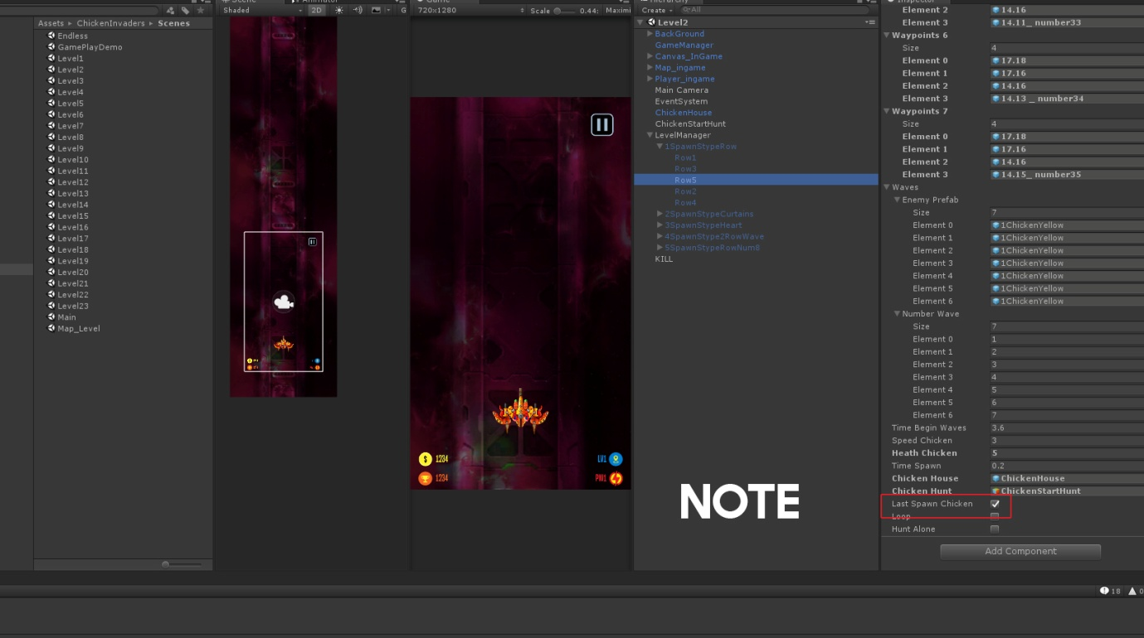
-4. All scripts of this project you can find in : Assets->Scripts. They are sorted by specific category. Read them if you want to learn more
-5. To find the method of displaying Unity Ads and Admob Ads. In Monodev, select "Search" -> "File in files" -> Search by keyword "// ads"
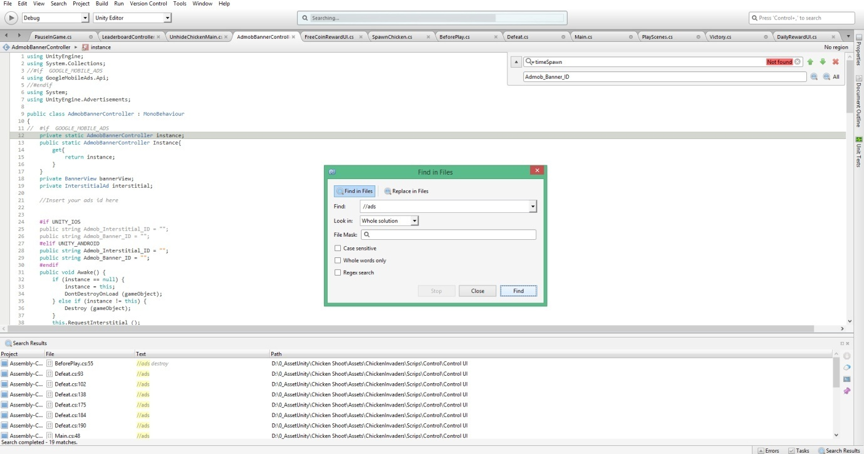
-6.
PlayerPrefs.Getint("Level"); Save current level selected
PlayerPrefs.Getint("HighScore_"+ ...); Save score level ...
PlayerPrefs.Getint("TotalLevelDone"); Save level maps unlock
PlayerPrefs.Getint("Bought"); =0: Not Buy // = 1: Buy Bullet // = 2: Buy power // = 3: Buy Heath
PlayerPrefs.Getint("GOLD"); Amount Coins of player

-7. Important note when building iOS (Back to top)
The original project was to be in Android build mode. After you build apk for Android, then you want to build iOS then please follow these instructions to avoid errors:
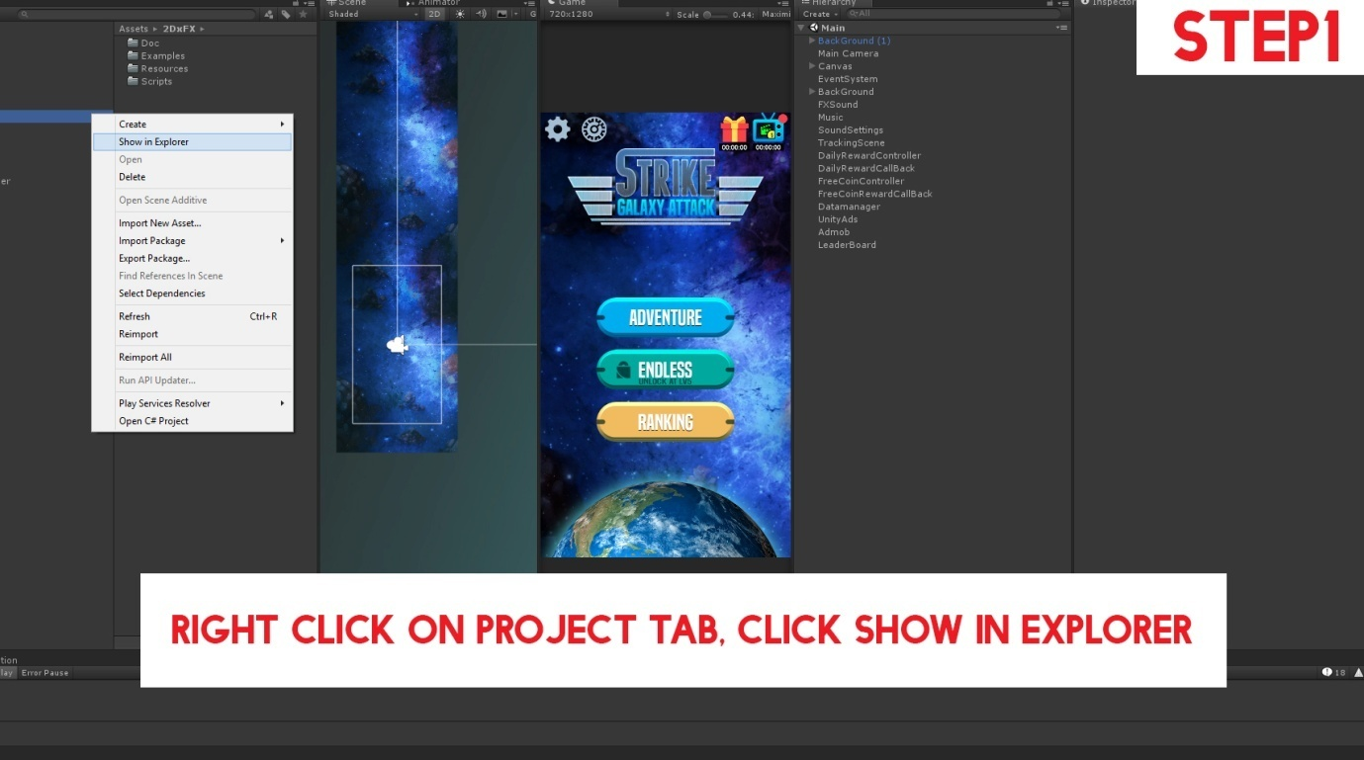

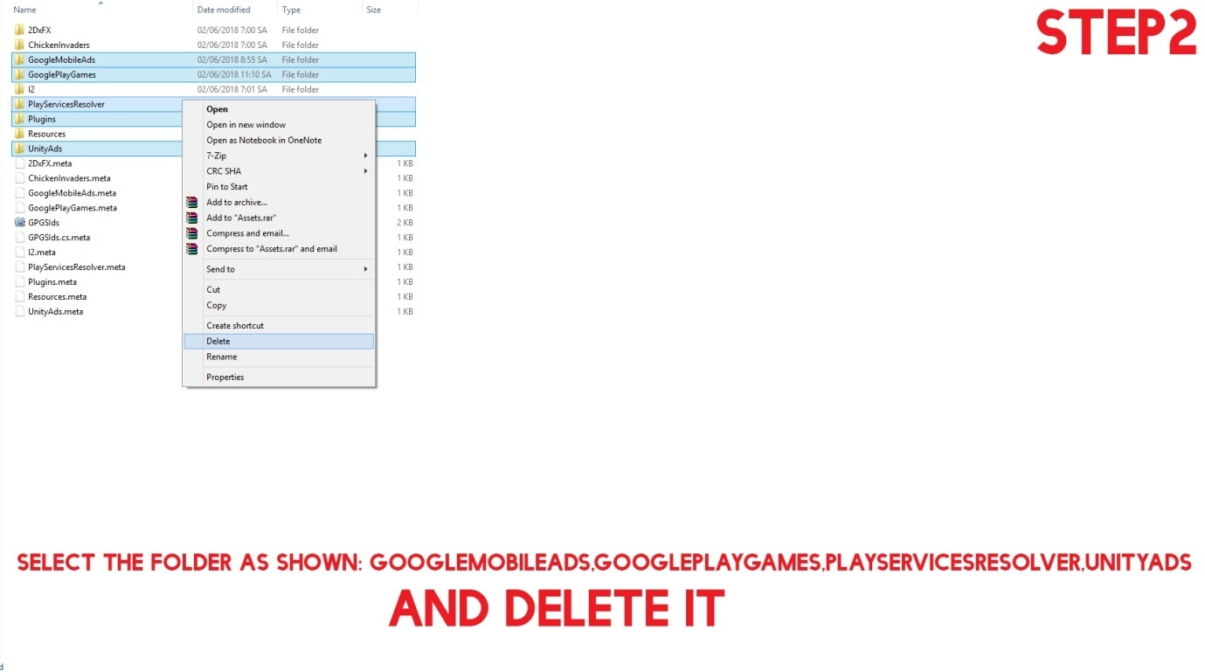
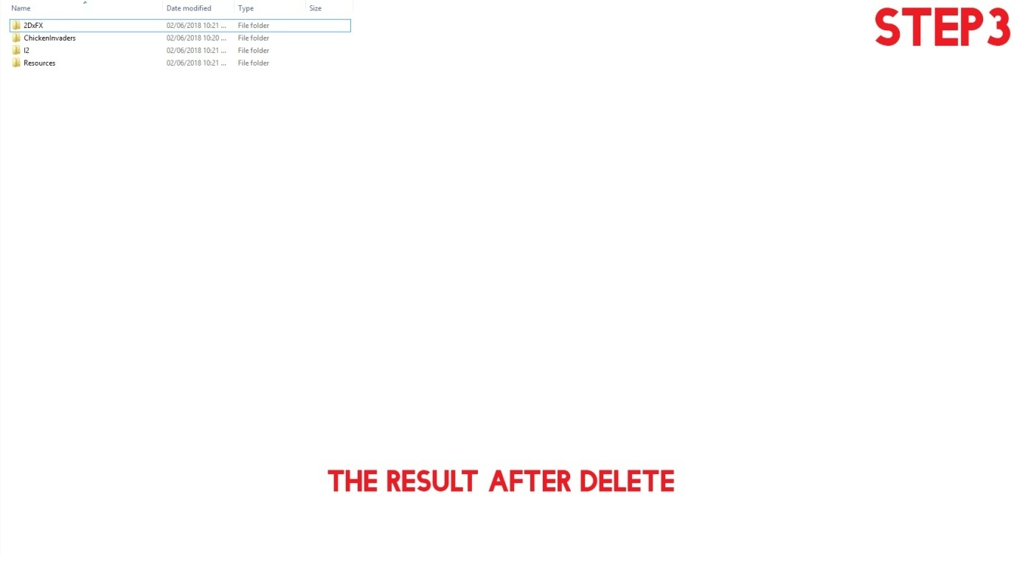

Step4 files: https://drive.google.com/file/d/1JjVwqYPiZfXB27pKn9tKu1dIRD-eKhxS/view
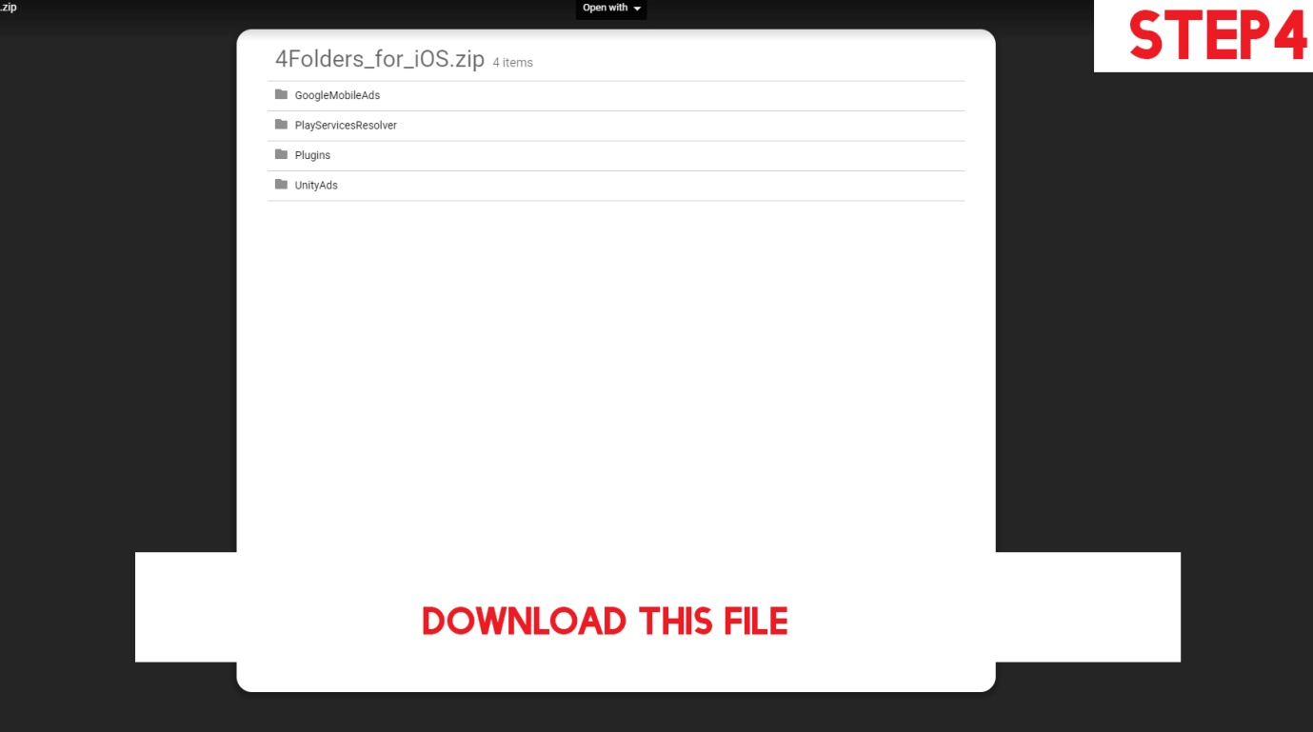
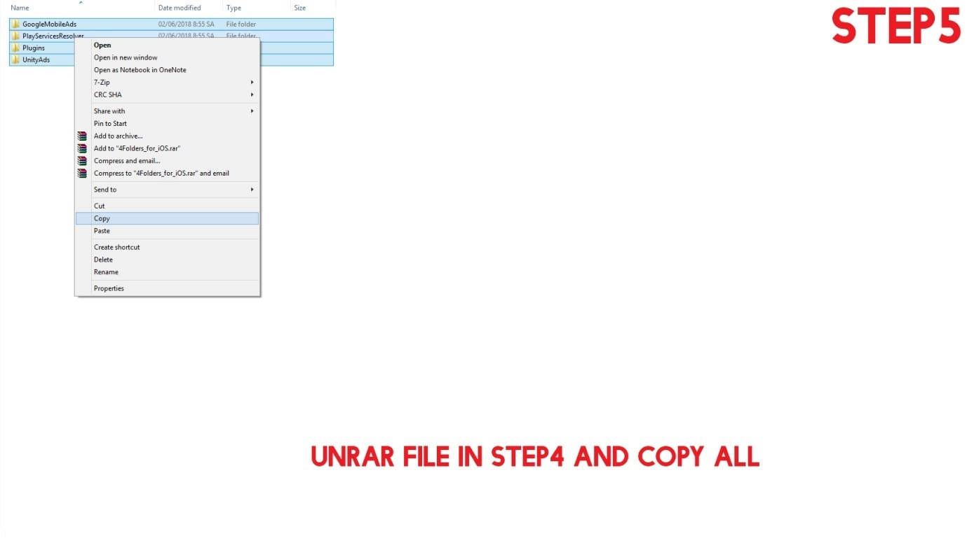

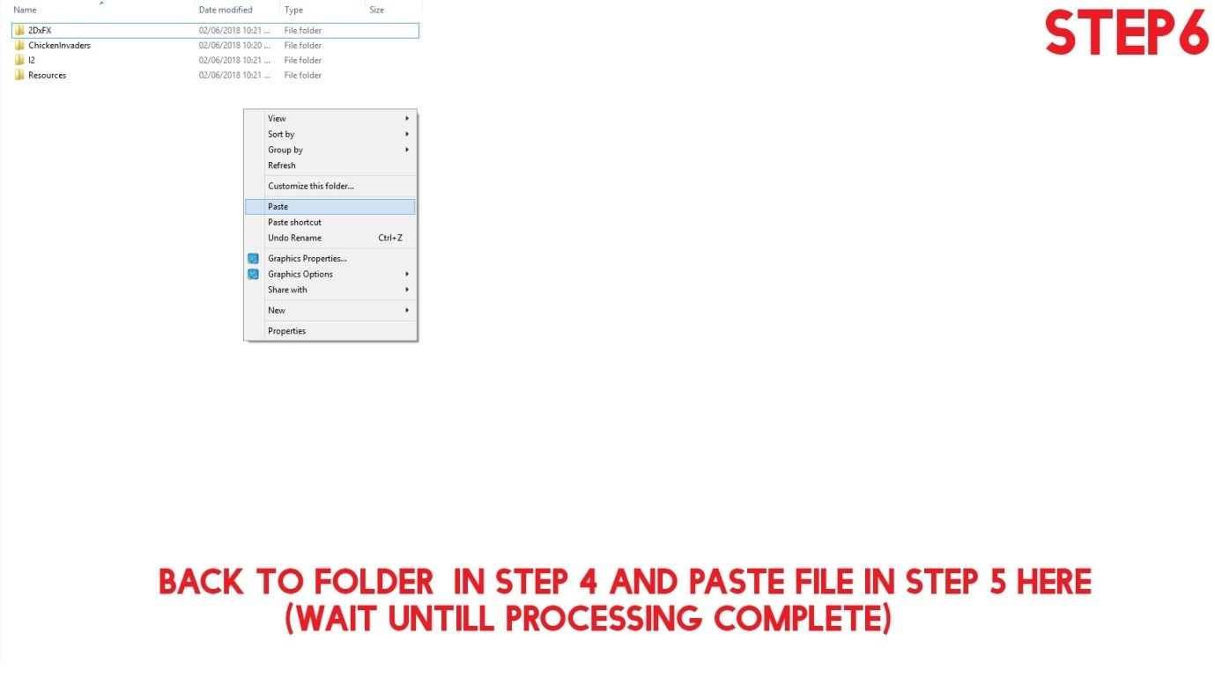
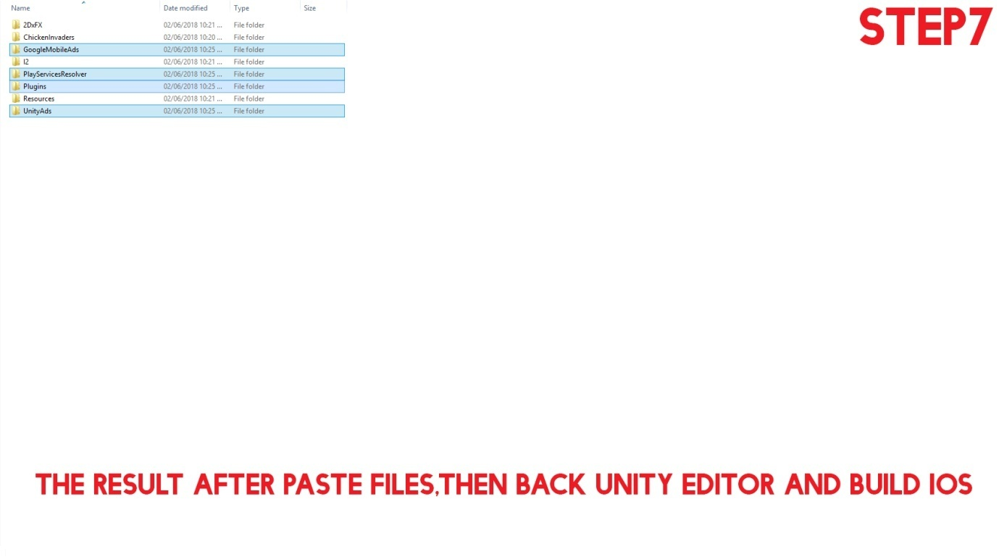 (Back to top)

